***Chemistry***

**2: Atoms, Molecules, and Ions**

**2.4: Chemical Formulas**

27. Explain why the symbol for an atom of the element oxygen and the formula for a molecule of oxygen differ.

Solution

The symbol for the element oxygen, O, represents both the element and one atom of oxygen. A molecule of oxygen, O2, contains two oxygen atoms; the subscript 2 in the formula must be used to distinguish the diatomic molecule from two single oxygen atoms.

29. Write the molecular and empirical formulas of the following compounds:

(a)

L:\Clients\Connexions\CONNEX130016_Chemistry\02_Working_Files\C02_Atoms and Molecules\99_Current_Art\JPEG\CNX_Chem_02_04_Question3a_img.jpg

(b)

L:\Clients\Connexions\CONNEX130016_Chemistry\02_Working_Files\C02_Atoms and Molecules\99_Current_Art\JPEG\CNX_Chem_02_04_Question3b_img.jpg

(c)

**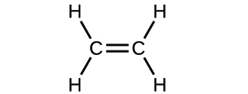**

(d)

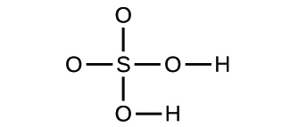

Solution

(a) molecular CO2, empirical CO2; (b) molecular C2H2, empirical CH; (c) molecular C2H4, empirical CH2; (d) molecular H2SO4, empirical H2SO4

31. Determine the empirical formulas for the following compounds:

(a) caffeine, C8H10N4O2

(b) fructose, C12H22O11

(c) hydrogen peroxide, H2O2

(d) glucose, C6H12O6

(e) ascorbic acid (vitamin C), C6H8O6

Solution

(a) C4H5N2O; (b) C12H22O11; (c) HO; (d) CH2O; (e) C3H4O3

33. Write the empirical formulas for the following compounds:

(a)

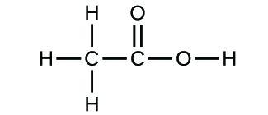

(b)



Solution

(a) CH2O; (b) C2H4O

35. Use the URL: <http://phet.colorado.edu/en/simulation/build-a-molecule> to repeat Exercise 8, but build a molecule with two carbons, six hydrogens, and one oxygen.

(a) Draw the structural formula of this molecule and state its name.

(b) Can you arrange these atoms to make a different molecule? If so, draw its structural formula and state its name.

(c) How are the molecules drawn in (a) and (b) the same? How do they differ? What are they called (the type of relationship between these molecules, not their names).

Solution

(a) ethanol

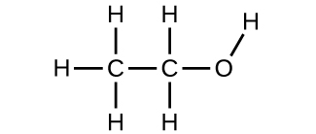

(b) methoxymethane, more commonly known as dimethyl ether

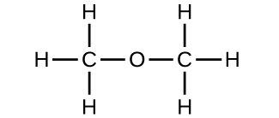

(c) These molecules have the same chemical composition (types and number of atoms) but different chemical structures. They are structural isomers.

This resource file is copyright 2015, Rice University. All Rights Reserved.